**Project Specification Document**

1. **Project and Developer details:**
   1. **Project details:**

* Welcome page with admin username and password.
* Wrong Username or password its shows invalid credentials.
* Right Username and password it will allow you enter admin home page.
* Admin Home Page show you list of option:
* 1) Classes
* 2)Subjects
* 3)Teachers
* 4)Students
* 5)Logoff
* 1)Classes: This option allows admin select class, subject and teacher.
* Admin can select class from eight, nine and ten.
* Subject from given list.
* Teachers from given list.
* Classes details: its show all details(class name, subject ,teacher and list of student) about every class.
* 2)Subjects: This option shows all subjects name with subject ID.
* 3)Teachers: This option shows all teachers name with basic details like first name, last name, age, address, and phone number.
* 4)Student: This option shows all student name with basic details like roll number, first name, last name, class, address, and phone number.
* 5)Logoff: This option allow admin to logoff from admin home page.
* Logoff successfully from admin home page
* After logoff show option for login back to admin page if you click on login back it will be redirected to welcome page
  1. **Developer Details:**

Application is developed Chhaya Askar and As a Full Stack Developer, I have designed and developed a portal for the Learner’s Academy named as “**Backend Admin for Learner’s Academy**”. The goal of the company is to deliver a high-end quality product as early as possible.

**2. Sprint Planning:**

**Task 1**: **Welcome page** with admin username and password.

* Wrong Username or password its shows invalid credentials.
* Right Username and password it will allow you enter admin home page.

**Task 2**: **Admin Home Page** show you list of option:

* 1) Classes
* 2)Subjects
* 3)Teachers
* 4)Students
* 5)Logoff

**Task 3:** **Classes:** This option allows admin select class, subject and teacher.

* Admin can select class from eight, nine and ten.
* Subject from given list.
* Teachers from given list.
* Classes details: its show all details (class name, subject, teacher, and list of students) about every class.

**Task 4**: **Subjects**: This option shows all subjects name with subject ID.

**Teachers**: This option shows all teachers name with basic details like first name, last name, age, address, and phone number.

**Student:** This option shows all student name with basic details like roll number, first name, last name, class, address, and phone number.

**Task 5**: **Logoff**: This option allow admin to logoff from admin home page.

* Logoff successfully from admin home page
* After logoff show option for login back to admin page if you click on login back it will be redirected to welcome page

**3. Flowchart:**

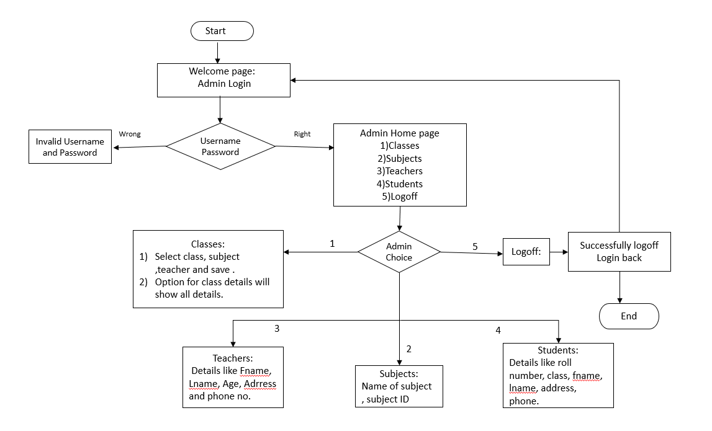

**4. Core concepts used in the project Concepts used in developing the application are**

1. Eclipse IDE
2. MySQL Relation Database Management System
3. Apache Tomcat server
4. Java Servlets
5. Java Server Pages (JSP)
6. HTML
7. JDBC Java Database Connectivity
8. SQL

**5. Links to the GitHub repository to verify the project completion**